Skin Disease Classification Using Deep Learning and Explainable Artificial Intelligence

Project Documentation

Abstract
Skin diseases affect millions of people worldwide and early diagnosis is essential for effective treatment. Manual diagnosis by dermatologists requires considerable expertise and may be time-consuming, especially when large numbers of patients need to be examined. Recent advances in Deep Learning and Computer Vision have enabled automated skin disease classification systems that can assist healthcare professionals by providing fast and reliable predictions.
This project presents an end-to-end deep learning-based skin disease classification system using the HAM10000 dataset. The proposed system classifies dermoscopic images into seven different skin disease categories: Melanoma, Melanocytic Nevus, Basal Cell Carcinoma, Benign Keratosis, Actinic Keratosis, Dermatofibroma, and Vascular Lesion.
The project follows a complete deep learning workflow consisting of data understanding, image preprocessing, exploratory data analysis, custom Convolutional Neural Network (CNN) development, transfer learning using MobileNetV2, EfficientNetB0, ResNet50, and DenseNet121, model optimization, performance evaluation, Explainable Artificial Intelligence (XAI), and deployment through a Flask web application.
Several optimization techniques, including data augmentation, batch normalization, dropout, optimizer comparison, batch size comparison, learning rate scheduling, early stopping, fine-tuning, and hyperparameter optimization, were applied to improve model performance. The trained models were evaluated using Accuracy, Precision, Recall, F1 Score, ROC-AUC, and Confusion Matrix. Explainable AI techniques such as Grad-CAM, Saliency Maps, Activation Maps, and Feature Map Visualization were incorporated to improve transparency and interpretability.
Finally, the best-performing model was deployed using Flask and Bootstrap to provide an interactive web interface where users can upload a skin image, receive disease predictions with confidence scores, visualize Grad-CAM heatmaps, compare model performance, and download diagnostic reports.
The proposed system demonstrates that deep learning combined with transfer learning and explainable AI can provide an efficient and reliable solution for automated skin disease classification while improving the transparency and trustworthiness of AI-assisted medical diagnosis.
Keywords: Deep Learning, Skin Disease Classification, CNN, Transfer Learning, TensorFlow, Explainable AI, Grad-CAM, Flask, HAM10000, Medical Image Analysis.

Chapter 1 – Introduction

1.1 Introduction
Skin diseases are among the most common medical conditions worldwide and can significantly affect an individual's health and quality of life. Early detection and accurate diagnosis are essential for providing appropriate treatment and reducing the risk of severe complications, particularly in the case of skin cancer. Traditionally, diagnosis relies on visual examination performed by experienced dermatologists, often supported by dermoscopic imaging. Although effective, this process requires considerable expertise and may not always be readily available, especially in regions with limited healthcare resources.
Recent developments in Artificial Intelligence (AI) and Deep Learning have transformed the field of medical image analysis. Convolutional Neural Networks (CNNs) have demonstrated exceptional performance in automatically learning visual patterns from images without the need for manual feature extraction. Transfer learning further improves performance by leveraging knowledge from models pretrained on large image datasets, reducing training time and improving classification accuracy even with relatively limited medical data.
In this project, a comprehensive deep learning framework was developed for automatic skin disease classification using the HAM10000 dataset. Multiple custom CNN architectures and transfer learning models were trained and compared under identical preprocessing conditions. Various optimization techniques were employed to improve model performance, and Explainable Artificial Intelligence methods were integrated to provide visual explanations for each prediction.
The final model was deployed using Flask and Bootstrap to provide an easy-to-use web application capable of predicting skin diseases from uploaded images while presenting confidence scores and explainability visualizations.

1.2 Problem Statement
Accurate diagnosis of skin diseases requires significant clinical experience and access to dermatological expertise. In many healthcare settings, delays in diagnosis or limited specialist availability can affect patient outcomes. Manual examination is also subject to variability among clinicians, particularly when different skin diseases exhibit similar visual characteristics.
Although deep learning models have shown promising results in image classification, many existing systems focus solely on prediction accuracy and provide little explanation for their decisions. This lack of interpretability reduces user confidence and limits adoption in medical applications.
Therefore, there is a need for an intelligent system that not only classifies skin diseases with high accuracy but also provides visual explanations of its predictions through Explainable AI techniques. Such a system can assist healthcare professionals by offering fast, consistent, and transparent decision support.

1.3 Objectives
The primary objective of this project is to develop an end-to-end deep learning application capable of automatically classifying skin diseases from dermoscopic images.
The specific objectives are:
- To analyze and understand the HAM10000 skin disease dataset.
- To preprocess medical images through resizing, normalization, augmentation, and class imbalance handling.
- To develop multiple custom CNN architectures for skin disease classification.
- To implement and compare transfer learning models including MobileNetV2, EfficientNetB0, ResNet50, and DenseNet121.
- To improve model performance using data augmentation, batch normalization, dropout, optimizer comparison, batch size comparison, learning rate scheduling, early stopping, fine-tuning, and hyperparameter optimization.
- To evaluate each model using Accuracy, Precision, Recall, F1 Score, ROC-AUC, Confusion Matrix, and classification reports.
- To implement Explainable Artificial Intelligence techniques such as Grad-CAM, Saliency Maps, Activation Maps, and Feature Map Visualization.
- To deploy the best-performing model using a Flask web application with an intuitive Bootstrap-based user interface.
- To provide users with disease predictions, confidence scores, probability distributions, visual explanations, and downloadable reports.

Chapter 2 – Dataset and Methodology

2.1 Dataset Description
The HAM10000 (Human Against Machine with 10,000 Training Images) dataset is a publicly available benchmark dataset widely used for skin lesion classification research. It contains dermoscopic images collected from different clinical sources and represents seven common categories of pigmented skin lesions. The dataset provides high-quality images along with metadata such as lesion ID, diagnosis, age, gender, and lesion location.
The dataset used in this project contains approximately 10,015 dermoscopic images belonging to seven disease classes. Since the dataset is highly imbalanced, special preprocessing techniques were applied to improve the learning capability of the deep learning models.

Skin Disease Classes
Class | Description
Melanoma (MEL) | A dangerous type of skin cancer that develops from melanocytes.
Melanocytic Nevus (NV) | Commonly known as a mole and generally considered benign.
Basal Cell Carcinoma (BCC) | A common form of skin cancer that grows slowly.
Benign Keratosis (BKL) | Non-cancerous skin growths that appear due to aging.
Actinic Keratosis (AKIEC) | A precancerous skin lesion caused by prolonged sun exposure.
Dermatofibroma (DF) | A benign fibrous skin tumor.
Vascular Lesion (VASC) | Skin abnormalities formed due to blood vessel disorders.

Dataset Splitting
The dataset was divided into three subsets to ensure proper model evaluation.
Dataset | Percentage | Purpose
Training Set | 70% | Model training
Validation Set | 15% | Hyperparameter tuning and validation
Test Set | 15% | Final performance evaluation
The split was performed using stratified sampling to preserve the class distribution across all subsets

Chapter 3 – Methodology
The proposed system follows a complete deep learning workflow beginning with data collection and ending with deployment through a Flask web application. Figure 3.1 illustrates the overall methodology adopted in this project.
Figure 3.1: Overall Project Workflow
Dataset Collection → Data Understanding → Image Preprocessing → Exploratory Data Analysis → CNN Model Development → Transfer Learning → Model Optimization → Model Evaluation → Explainable AI → Flask Deployment
The workflow ensures that every stage contributes to improving model performance and reliability while maintaining consistency across different deep learning architectures.

Chapter 4 – Project Implementation

4.1 Phase 1 – Data Understanding
The first phase focused on understanding the HAM10000 dataset before model development. Exploratory analysis was performed to identify the characteristics of the images and understand the distribution of disease classes.
The following analyses were carried out:
- Examination of dataset dimensions and metadata.
- Identification of different disease categories.
- Analysis of class imbalance.
- Visualization of sample images.
- Image resolution analysis.
- Train, validation, and test dataset splitting.
The analysis revealed that the Melanocytic Nevus (NV) class contained significantly more images than the remaining classes. This imbalance could lead to biased model predictions if not properly handled.

Outputs Generated
- Dataset summary
- Sample image visualization
- Class distribution graph
- Image resolution statistics
- Train–validation–test split visualization

4.2 Phase 2 – Data Preprocessing
Medical image preprocessing plays a critical role in improving model performance by ensuring that every image is presented in a consistent format.
Several preprocessing operations were applied before model training.

Image Resizing
All dermoscopic images were resized to 224 × 224 pixels to satisfy the input size requirements of the custom CNNs and transfer learning models.

Pixel Normalization
Pixel values originally ranged from 0 to 255. These values were normalized to the range 0–1 by dividing each pixel value by 255. This normalization improves numerical stability during training and accelerates convergence.

Image Augmentation
To improve generalization and reduce overfitting, multiple augmentation techniques were applied only to the training dataset.
The augmentation techniques included:
- Horizontal Flip
- Vertical Flip
- Random Rotation
- Random Zoom
- Random Brightness Adjustment
- Random Contrast Adjustment
- Random Crop
These transformations generated diverse training samples while preserving the original disease characteristics.

Handling Class Imbalance
The HAM10000 dataset contains an uneven distribution of disease classes. To reduce prediction bias toward majority classes, class weights were computed using the compute_class_weight() function from Scikit-learn.
These class weights were supplied during model training, ensuring that misclassification of minority classes incurred a higher penalty.

TensorFlow Data Pipeline
Efficient data loading was implemented using the TensorFlow tf.data API.
The pipeline included:
- Reading image paths.
- Image decoding.
- Image resizing.
- Pixel normalization.
- Data augmentation.
- Batch creation.
- Prefetching for improved GPU utilization.
The use of TensorFlow data pipelines significantly reduced memory usage and improved training efficiency.

4.3 Phase 3 – Exploratory Data Analysis
Exploratory Data Analysis (EDA) was performed to understand the characteristics of the processed dataset and validate preprocessing operations.
The following analyses were conducted:

Class Distribution
A bar chart was created to visualize the number of images in each disease category. This confirmed the existence of severe class imbalance.

Pixel Intensity Analysis
The average pixel intensity distribution was analyzed to ensure that normalization produced consistent image values suitable for deep learning models.

Image Augmentation Comparison
Original images were visually compared with augmented images to verify that augmentation preserved essential diagnostic features while increasing dataset diversity.

Class-wise Image Characteristics
Representative images from each disease class were displayed for visual comparison. This helped identify differences in lesion color, texture, size, and boundary characteristics.
The exploratory analysis verified that the preprocessing pipeline successfully prepared the dataset for deep learning training.

4.4 Phase 4 – Model Development
The core objective of this phase was to develop and compare multiple deep learning architectures under identical preprocessing conditions.
Two categories of models were implemented.

Custom CNN Models
The following custom architectures were developed from scratch:
- Basic CNN
- Deep CNN
- CNN with Batch Normalization
- CNN with Dropout
These models were designed to learn hierarchical image features directly from the HAM10000 dataset.

Transfer Learning Models
To improve classification performance, four pretrained convolutional neural networks were employed:
- MobileNetV2
- EfficientNetB0
- ResNet50
- DenseNet121
The pretrained convolutional layers acted as feature extractors, while new classification layers were added for the seven skin disease classes.
Each transfer learning model consisted of:
- Pretrained convolutional base
- Global Average Pooling layer
- Fully Connected Dense layer
- Dropout layer
- Softmax output layer
All models were trained using identical datasets, preprocessing techniques, loss functions, and evaluation metrics to ensure a fair comparison.

Chapter 5 – Model Improvement

5.1 Introduction
Although the baseline CNN and transfer learning models produced satisfactory results, further improvements were required to enhance classification accuracy, reduce overfitting, and improve the generalization capability of the models. Several optimization techniques were implemented and evaluated individually to identify the best-performing configuration.
The same improvement strategies were applied to both the custom CNN models and the transfer learning models to ensure a fair comparison.

5.2 Data Augmentation
Medical image datasets are often limited in size and exhibit high similarity between samples. To improve model robustness, data augmentation techniques were applied to the training dataset.
The augmentation techniques included:
- Horizontal Flip
- Vertical Flip
- Random Rotation
- Random Zoom
- Random Brightness Adjustment
- Random Contrast Adjustment
- Random Crop
These transformations generated multiple variations of the original images without altering the disease characteristics. As a result, the models were exposed to a larger variety of training samples, reducing overfitting and improving their ability to generalize to unseen images.

5.3 Batch Normalization
Batch Normalization layers were introduced into the CNN architectures to stabilize the distribution of feature values during training.
The primary benefits observed were:
- Faster convergence during training.
- Reduced internal covariate shift.
- Improved gradient flow.
- Higher training stability.
- Better validation accuracy.
The models with Batch Normalization demonstrated smoother learning curves and required fewer epochs to reach convergence.

5.4 Dropout Regularization
Dropout was applied after the fully connected layers to minimize overfitting.
Different dropout rates were experimentally evaluated:
Dropout Rate | Purpose
0.30 | Mild regularization
0.50 | Balanced regularization
0.70 | Strong regularization
A dropout rate of 0.50 provided the best balance between learning capacity and generalization for most models.

5.5 Early Stopping
To prevent unnecessary training and avoid overfitting, the Early Stopping callback was employed.
The validation loss was continuously monitored during training. If no improvement was observed for several consecutive epochs, the training process was terminated automatically, and the model weights corresponding to the lowest validation loss were restored.
This optimization reduced training time while preserving the best-performing model.

5.6 Learning Rate Scheduling
The learning rate significantly influences the convergence behavior of deep learning models.
A learning rate scheduler was incorporated to dynamically reduce the learning rate whenever the validation performance plateaued.
Advantages included:
- Faster convergence.
- Stable optimization.
- Reduced oscillations.
- Improved final accuracy.
The scheduler enabled the optimizer to perform coarse updates during the initial training stages and finer updates during later stages.

5.7 Optimizer Comparison
Three widely used optimization algorithms were compared.
Optimizer | Characteristics
Adam | Adaptive learning rate with fast convergence.
SGD with Momentum | Stable optimization with improved generalization.
RMSprop | Adaptive optimization suitable for image classification.
Each optimizer was trained under identical conditions, allowing a direct comparison of convergence speed and validation accuracy.
The optimizer producing the highest validation accuracy was selected as the preferred optimizer for subsequent experiments.

5.8 Batch Size Comparison
The influence of batch size on model performance was investigated.
The following batch sizes were evaluated:
- Batch Size = 16
- Batch Size = 32
- Batch Size = 64
Smaller batch sizes generally produced better generalization but required longer training times, while larger batch sizes reduced computation time at the expense of slight reductions in validation accuracy.
The optimal batch size was selected based on the best trade-off between computational efficiency and classification performance.

5.9 Fine-Tuning Transfer Learning Models
Initially, the pretrained convolutional layers of MobileNetV2, EfficientNetB0, ResNet50, and DenseNet121 were frozen to preserve the learned ImageNet features.
After training the newly added classification layers, selected upper convolutional layers were unfrozen and fine-tuned using a smaller learning rate.
Fine-tuning enabled the pretrained models to adapt more effectively to dermoscopic skin images, resulting in improved feature extraction and higher classification accuracy.

5.10 Hyperparameter Optimization
Selecting appropriate hyperparameters is essential for maximizing model performance.
The following hyperparameters were optimized:
- Number of convolution filters.
- Number of dense neurons.
- Learning rate.
- Optimizer.
- Dropout rate.
- Batch size.
Hyperparameter tuning was performed using Keras Tuner, which automatically evaluated multiple model configurations and identified the combination producing the highest validation accuracy.
The optimized model demonstrated superior performance compared to the baseline architecture.

Chapter 6 – Model Evaluation

6.1 Introduction
After training and optimization, every model was evaluated using multiple classification metrics to obtain a comprehensive assessment of performance.
The evaluation process compared both custom CNN models and transfer learning models under identical testing conditions.

6.2 Accuracy
Accuracy represents the percentage of correctly classified skin lesion images.
It is calculated as:
Accuracy = (Correct Predictions / Total Predictions) × 100
Although accuracy provides an overall indication of performance, it is insufficient for imbalanced datasets because majority classes can dominate the result.

6.3 Precision
Precision measures the proportion of predicted positive samples that are actually correct.
High precision indicates that the model produces fewer false-positive predictions.
This metric is particularly important in medical diagnosis because incorrect positive predictions may lead to unnecessary treatments.

6.4 Recall
Recall measures the proportion of actual positive samples correctly identified by the model.
High recall is crucial for skin disease diagnosis because failing to detect a malignant lesion may have severe clinical consequences.

6.5 F1 Score
The F1 Score combines Precision and Recall into a single metric using their harmonic mean.
It provides a balanced evaluation for datasets containing imbalanced classes.

6.6 ROC-AUC
Receiver Operating Characteristic (ROC) curves were generated for every disease class.
The Area Under the Curve (AUC) was calculated to measure the discrimination capability of each model.
Higher ROC-AUC values indicate stronger classification performance across different decision thresholds.

6.7 Confusion Matrix
A confusion matrix was generated to visualize prediction performance for every disease category.
The matrix illustrates:
- Correct classifications.
- False positives.
- False negatives.
- Class-wise prediction errors.
This visualization helped identify disease classes that were difficult to distinguish from one another.

6.8 Training Curves
Training and validation accuracy curves were plotted for every model.
Similarly, training and validation loss curves were generated to observe convergence behavior and detect overfitting.
These plots provided valuable insight into the learning dynamics of each architecture.

6.9 Precision–Recall Curves
Precision–Recall curves were generated for every disease class.
These curves are particularly useful for evaluating classification performance on imbalanced medical datasets because they focus on positive predictions rather than overall accuracy.

6.10 Misclassified Images
Misclassified test images were visualized to investigate model limitations.
This analysis revealed challenging cases where diseases shared similar visual characteristics, helping identify opportunities for further model improvement.

6.11 Comparative Performance Analysis
The performance of all developed models was compared using identical evaluation metrics.
The comparison included:
- Basic CNN
- Deep CNN
- CNN with Batch Normalization
- CNN with Dropout
- MobileNetV2
- EfficientNetB0
- ResNet50
- DenseNet121
The model demonstrating the highest overall performance was selected for deployment in the Flask web application and for Explainable AI analysis.

Chapter 7 – Explainable Artificial Intelligence and Web Application

7.1 Explainable Artificial Intelligence (XAI)
Deep learning models generally function as black-box systems, where the reasoning behind predictions is not directly visible. In medical image analysis, prediction accuracy alone is not sufficient because healthcare professionals need to understand why a particular diagnosis was made. To improve transparency and trust, Explainable Artificial Intelligence (XAI) techniques were integrated into the proposed system.
The objective of XAI is to provide visual explanations that highlight the image regions contributing most to the model's prediction. These visualizations assist medical practitioners in verifying whether the model focuses on clinically relevant areas before making a decision.

Grad-CAM (Gradient-weighted Class Activation Mapping)
Grad-CAM was implemented to generate heatmaps that highlight the important regions of an image responsible for the predicted skin disease. The technique computes gradients flowing into the final convolutional layer and projects them onto the original image.
The generated heatmap enables users to identify the affected skin region that influenced the prediction, making the decision-making process more transparent.
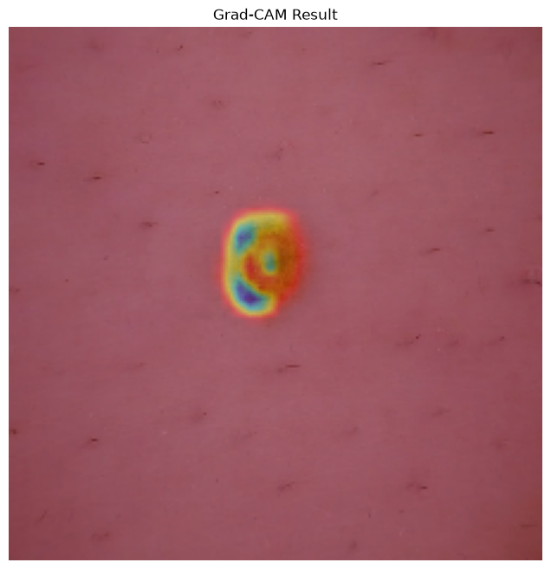

Figure 7.1: Grad-CAM Visualization

Saliency Maps
Saliency Maps visualize the importance of individual pixels by calculating the gradient of the predicted class with respect to the input image. Pixels with higher intensity indicate greater influence on the final prediction.
These maps provide another level of interpretability by showing which image regions contribute most significantly to the model's classification.
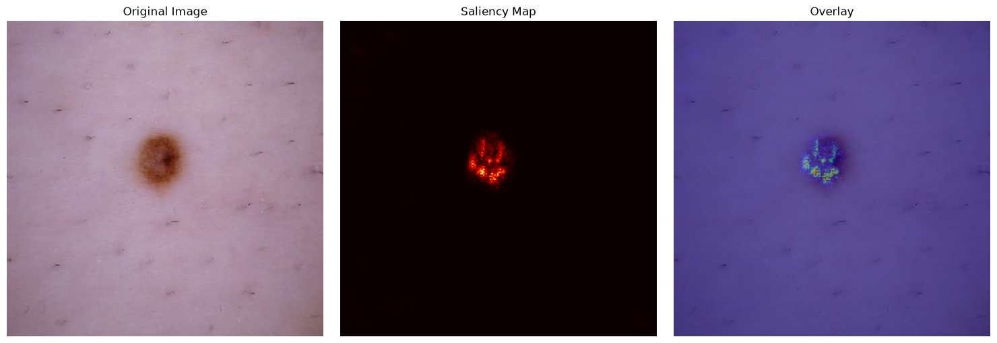
Figure 7.2: Saliency Map

Activation Maps
Activation Maps display the feature representations learned by different convolutional layers. Early layers generally capture edges and textures, while deeper layers identify complex patterns such as lesion shapes, color variations, and structural abnormalities.
By examining activation maps, it is possible to understand how the network progressively extracts meaningful features from dermoscopic images.

Feature Map Visualization
Feature map visualization provides insights into the intermediate outputs of convolutional filters. These visualizations demonstrate how different filters respond to various image characteristics such as color, texture, and lesion boundaries.
The analysis confirmed that deeper convolutional layers successfully captured discriminative features useful for skin disease classification.

Advantages of Explainable AI
The integration of Explainable AI provides several important benefits:
- Increases transparency of deep learning predictions.
- Builds trust among healthcare professionals.
- Helps verify whether the model focuses on clinically meaningful regions.
- Supports interpretation of complex neural network decisions.
- Improves confidence in AI-assisted medical diagnosis.

Chapter 8 – Flask Web Application

8.1 Overview
To make the trained deep learning model accessible to end users, a web application was developed using Flask and Bootstrap 5. The application provides an intuitive interface that allows users to upload skin lesion images and receive predictions instantly.
The Flask application integrates the trained model, image preprocessing pipeline, and Explainable AI visualizations into a single platform.

8.2 Features of the Web Application
The developed application includes the following features:
- User-friendly Bootstrap interface.
- Image upload functionality.
- Automatic image preprocessing.
- Skin disease prediction.
- Confidence score for predicted class.
- Probability distribution for all seven disease classes.
- Grad-CAM heatmap visualization.
- Model comparison dashboard.
- Downloadable diagnosis report.

System Workflow
The workflow of the web application is as follows:
- The user uploads a dermoscopic skin image.
- The uploaded image is resized and normalized.
- The trained deep learning model processes the image.
- The predicted disease class and confidence score are generated.
- Grad-CAM is applied to highlight the important image regions.
- The prediction results are displayed through the web interface.
- The user can download the diagnosis report.


Application Screenshots

Home Page
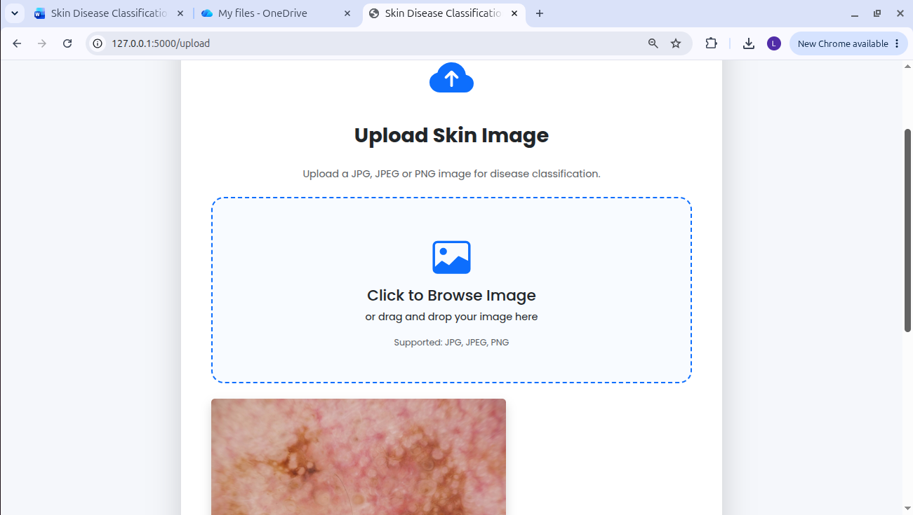
Upload Page
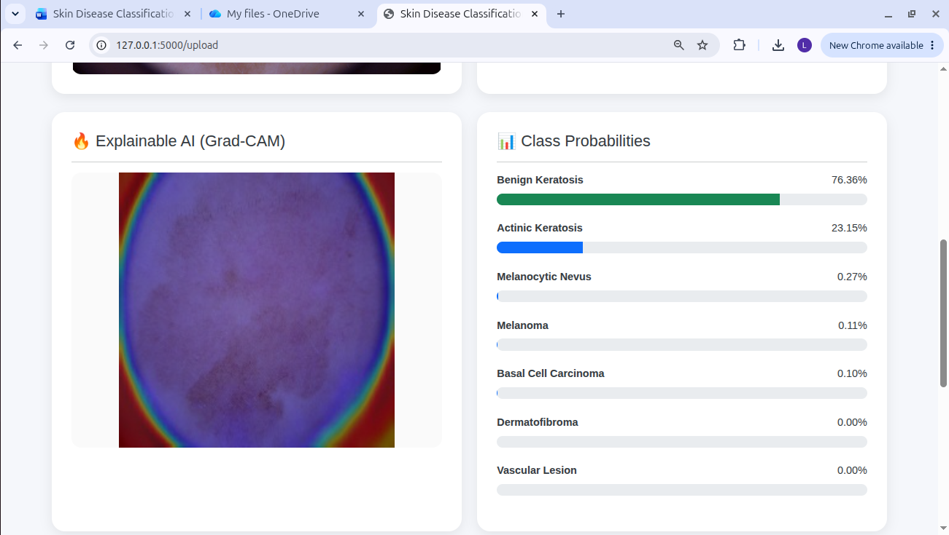
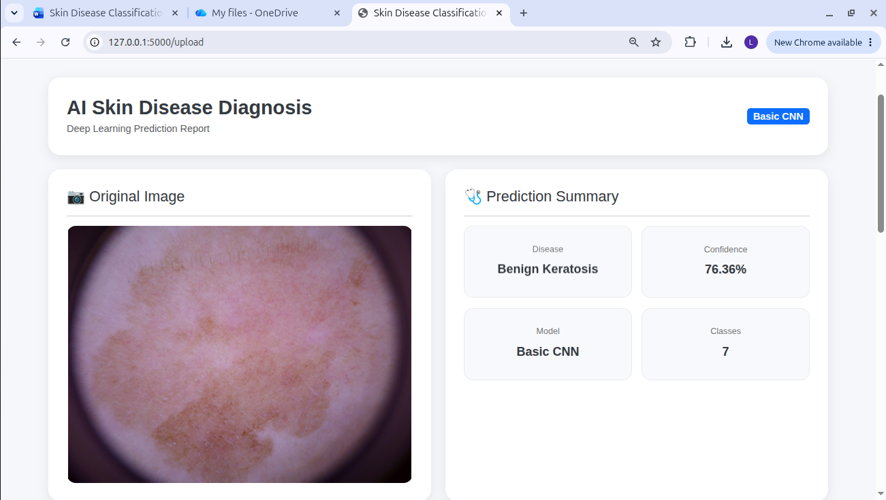
Prediction Page
Prediction results with Grad-CAM

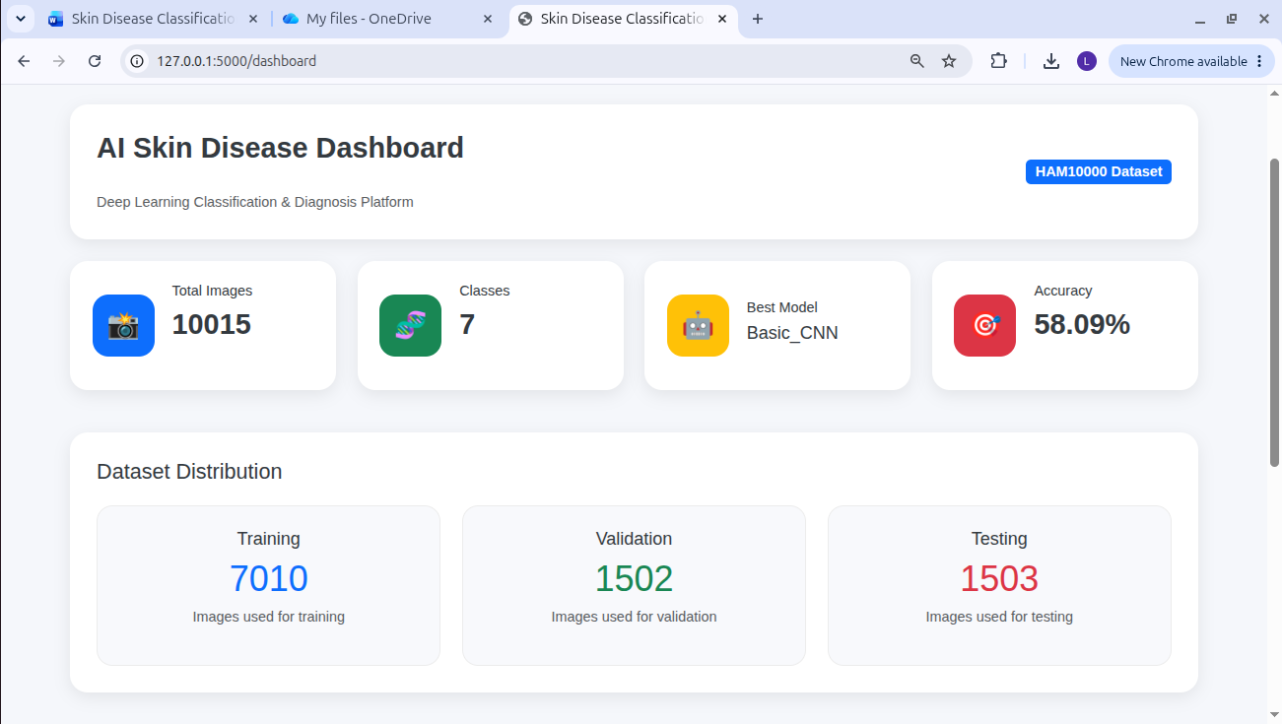
DashBoard Page

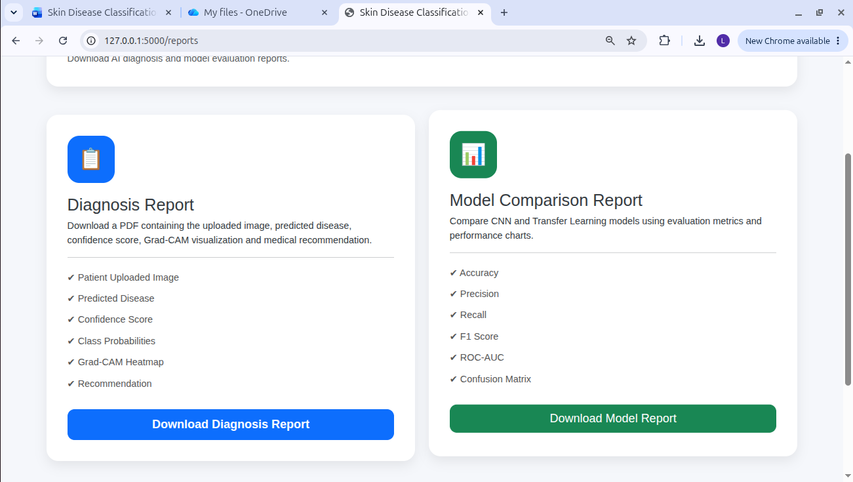
Report Page

Conclusion
This project successfully developed an end-to-end deep learning system for automated skin disease classification using the HAM10000 dataset. Multiple custom CNN architectures and transfer learning models, including MobileNetV2, EfficientNetB0, ResNet50, and DenseNet121, were implemented and evaluated under identical preprocessing conditions.
Several optimization techniques, including data augmentation, batch normalization, dropout, early stopping, learning rate scheduling, optimizer comparison, batch size comparison, fine-tuning, and hyperparameter optimization, were applied to improve model performance. The optimized models achieved improved classification accuracy and demonstrated strong generalization capabilities on unseen test data.
Explainable Artificial Intelligence techniques such as Grad-CAM, Saliency Maps, Activation Maps, and Feature Map Visualization enhanced the interpretability of the model by highlighting the image regions responsible for predictions. Finally, the best-performing model was deployed using a Flask and Bootstrap web application, enabling users to upload images, receive predictions with confidence scores, visualize explanation heatmaps, and download diagnostic reports.
The proposed system demonstrates that deep learning combined with transfer learning and Explainable AI can provide an effective, transparent, and practical solution for automated skin disease classification, supporting healthcare professionals in clinical decision-making.

